- Waszyngton. Vaugan Place. [1]
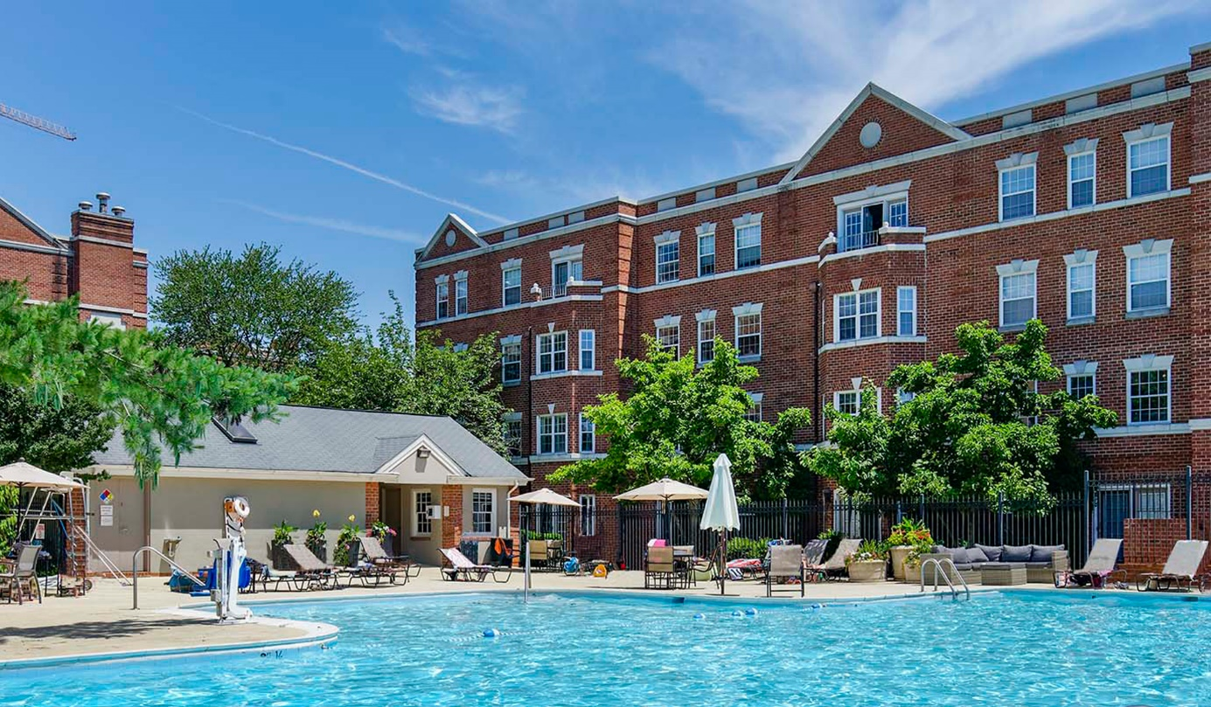
https://www.vaughanplace.com/en/apartments/featured-amenity.html

- Gold Coast. Fraser Propoerty. [4]
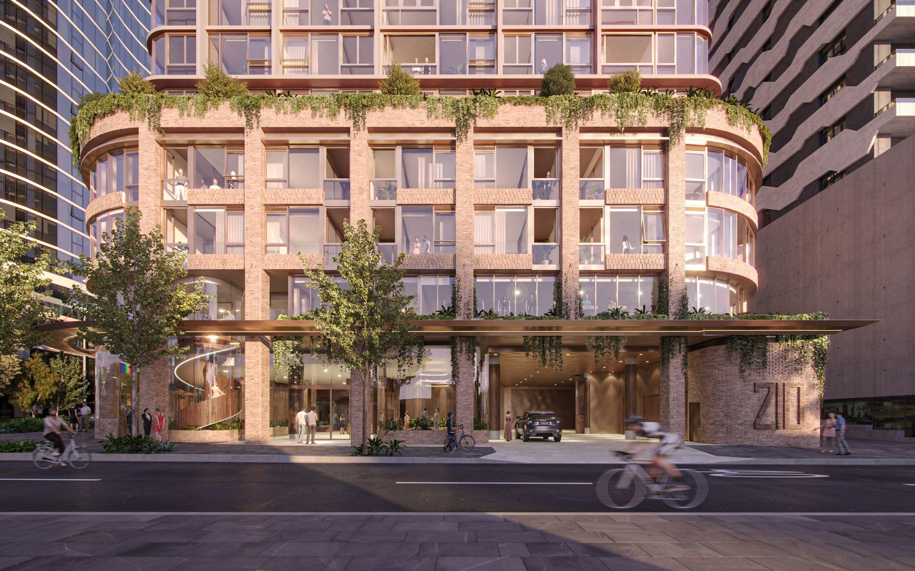
Źródło: https://www.frasersproperty.com.au/Media-Centre/News/2021/09/17/Hutchinson-Builders-Appointed
- Jubail Island. [6]
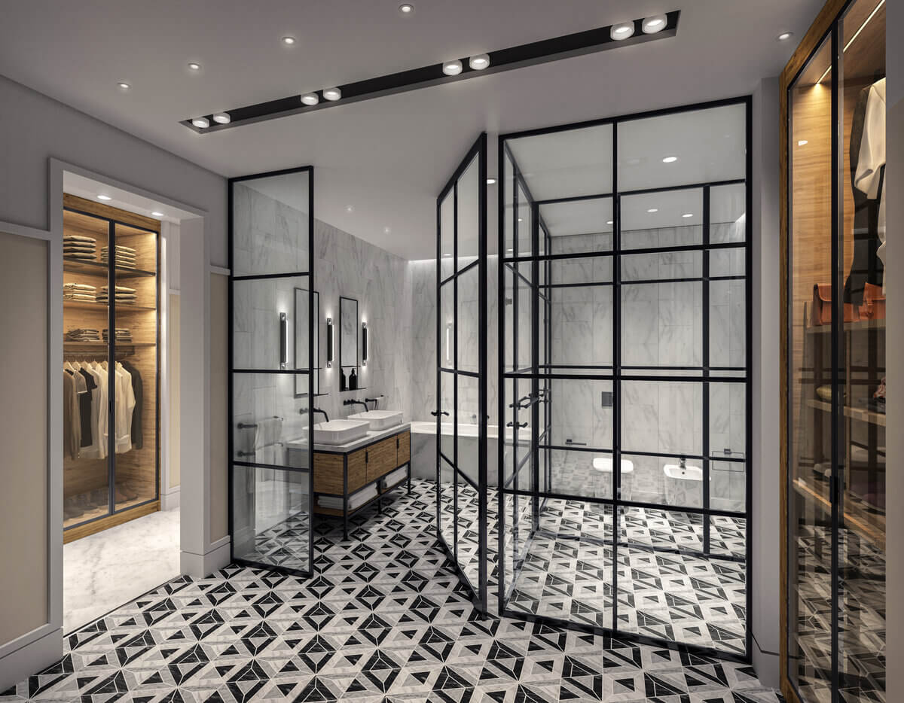
Źródło: https://www.jubailisland.ae/en/properties-en/villas/med-villas#filters

- Los Angeles. Modera Hollywood. [7]
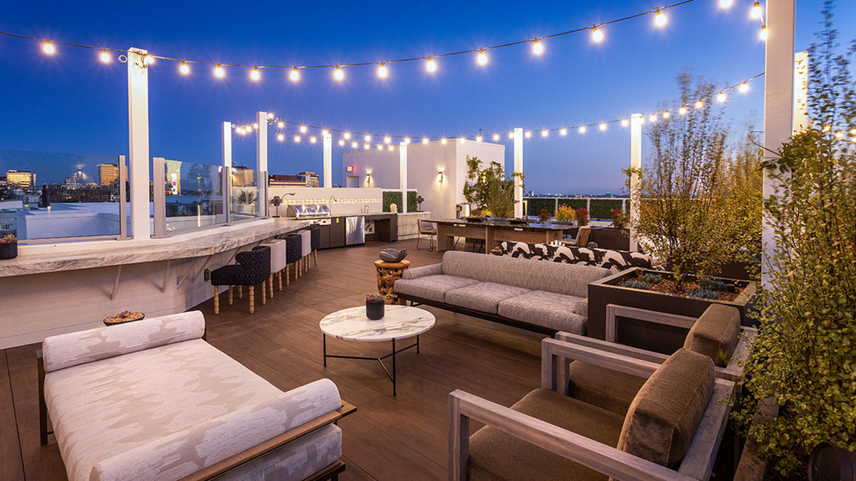
Źródło: https://www.moderahollywood.com/los-angeles-ca-apartments/modera-hollywood/photos/

